**Advanced Database Management Systems**

**Experiment-2**

**To understand the concept of data constraints that is enforced on data being stored in thetable. Focus on Primary Key and the Foreign Key**

**Aryan Mohan**

**500092142**

**Batch- 2**

CREATE DATABASE LabExperiment2;

USE LabExperiment2;

--Create the tables

CREATE TABLE client_master_1( CLIENT_NO CHAR(6) CHECK (CLIENT_NO like 'C%'), NAME VARCHAR(20) NOT NULL, ADDRESS1 VARCHAR(30), ADDRESS2 VARCHAR(30), CITY VARCHAR(15), PINCODE INTEGER, STATE VARCHAR(15), BAL_DUE DECIMAL(10,2), PRIMARY KEY(CLIENT_NO));

CREATE TABLE PRODUCT_MASTER_1( PRODUCT_NO CHAR(6) PRIMARY KEY, DESCRIPTION VARCHAR(15) NOT NULL, PROFITPERCENT DECIMAL (4,2) NOT NULL, UNITMEASURE VARCHAR(10) NOT NULL, QTYONHAND INTEGER NOT NULL, REORDERLVL INTEGER NOT NULL, SELLPRICE DECIMAL(8,2) NOT NULL, COSTPRICE DECIMAL(8,2) NOT NULL, CHECK(PRODUCT_NO like 'P%'));

CREATE TABLE SALESMAN_MASTER_1( SALESMAN_NO CHAR(6) NOT NULL, SALESMANNAME VARCHAR(20) NOT NULL, ADDRESS1 VARCHAR(30) NOT NULL, ADDRESS2 VARCHAR(30), CITY VARCHAR(20), PINCODE INTEGER, STATE VARCHAR(20), SALAMT DECIMAL(8,2) CHECK(SALAMT!=0) NOT NULL, TGTTOGET DECIMAL(6,2)CHECK(TGTTOGET!=0) NOT NULL, YTDSALES DECIMAL(6,2) NOT NULL, REMARKS VARCHAR(60), PRIMARY KEY(SALESMAN_NO), CONSTRAINT check_SALESMAN1_NO CHECK (SALESMAN_NO like 'S%'));

-- Reinsert the data in these two tables based upon Lab 1.

INSERT INTO client_master_1 VALUES('C00001', 'Ivan bayross','','', 'Mumbai', 400054,'Maharashtra', 15000);

INSERT INTO client_master_1 VALUES('C0002', 'Mamta muzumdar','','', 'Madras',780001,'Tamilnadu', 0);

INSERT INTO client_master_1 VALUES('C0003', 'Chhaya bankar','','', 'Mumbai','400057','Maharashtra', 5000);

INSERT INTO client_master_1 VALUES('C0004', 'Ashwini joshi','','', 'Bangalore','560001', 'Karnataka', 0);

INSERT INTO client_master_1 VALUES('C0005', 'Hansel colaco','','', 'Mumbai','400060','Maharashtra', 2000);

INSERT INTO client_master_1 VALUES('C0006', 'Deepak sharma','','', 'Mangalore','560050', 'Karnataka',0);

INSERT INTO PRODUCT_MASTER_1 VALUES('P00345','Shirts',6,'Piece',150,50,500,350);

INSERT INTO PRODUCT_MASTER_1 VALUES('P06734','Cotton jeans',5,'Piece',100,20,600,450);

INSERT INTO PRODUCT_MASTER_1 VALUES('P07865','Jeans',5, 'Piece',100,20,750,500);

INSERT INTO PRODUCT_MASTER_1 VALUES('P07868','Trous',2,'Piece',150,50,850,550);

INSERT INTO PRODUCT_MASTER_1 VALUES('P07885','Pull Overs',2.5,'Piece',80,30,700,450);

INSERT INTO PRODUCT_MASTER_1 VALUES('P07965','Denim jeans',4,'Piece',100,40,350,250);

insert into PRODUCT_MASTER_1 values ('P07975','Lycra tops',5,'Piece',70,30,300,175);

insert into PRODUCT_MASTER_1 values ('P08865','Skirts',5, 'Piece',75,30,450,300);

insert into SALESMAN_MASTER_1 values ('S00001', 'Aman', 'A/14', 'Worli', 'Mumbai',400002,'Maharashtra',100,60,80,'EXCELLENT');

insert into SALESMAN_MASTER_1 values ('S00002','Omkar','hno65','Nariman','Mumbai',400001,'Maharasht ra',70,500,170,'sat');

insert into SALESMAN_MASTER_1 values ('S00003','Raj','P7','Bandra','Mumbai',400032,'Maharashtra',85 ,75,100,'');

insert into SALESMAN_MASTER_1 values ('S00004','Ashish','A/5','Juhu','Mumbai',400044,'Maharashtra',50,500,800,'');

--Display the contents of each table.

select * from PRODUCT_MASTER_1;

select * from SALESMAN_MASTER_1;

**Output:**

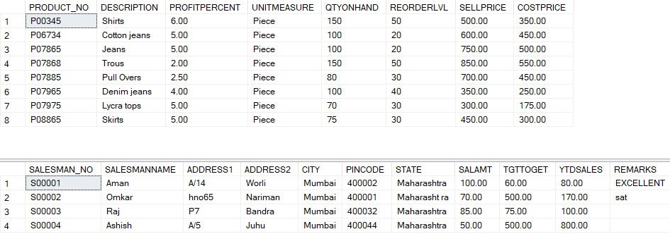

--Create table AUTHOR

Create table AUTHOR( Author_ID varchar(5) PRIMARY KEY NOT NULL, Lastname VARCHAR(15) NOT NULL, Firstname VARCHAR(15) NOT NULL, Email VARCHAR(50), City VARCHAR (15), Country VARCHAR(15) );

exec sp_columns AUTHOR;

**Output:**



--Create Table BOOK

Create Table BOOK( Book_ID VARCHAR(5) PRIMARY KEY CHECK(Book_ID LIKE 'B%'), Book_Title VARCHAR(40) NOT NULL, Copies INTEGER check(Copies>2) NOT NULL );

exec sp_columns BOOK;

**Output:**



--Create table AUTHOR_LIST

Create table AUTHOR_LIST ( Author_ID VARCHAR(5), Book_ID VARCHAR(5), Role VARCHAR(15), PRIMARY KEY(Author_ID, Book_ID), FOREIGN KEY(Author_ID) REFERENCES AUTHOR(Author_ID) );

exec sp_columns AUTHOR_LIST;

**Output:**



--Add four records in each tables AUTHOR, BOOK, BOOK_LIST.

insert into AUTHOR values ('A1011', 'Srinivasan', 'Singh','Srinivasan@gmail.com','Chennai', 'India');

insert into AUTHOR values ('A2121', 'Wu', 'JHOU', 'WU@YAHOO.COM','HONKONG', 'CHINA');

insert into AUTHOR values ('A5151', 'Mozart', 'GUPTA', 'GUPTA@GMAIL.COM', 'DELHI','INDIA');

insert into AUTHOR values ('A4001', 'vijendra', 'singh', 'vsingh@GMAIL.COM', 'dehradhun', 'INDIA');

select * from AUTHOR; insert into BOOK values ('B1001', 'DATA BASE SYSTEM',20); select * from BOOK;

**Output:**

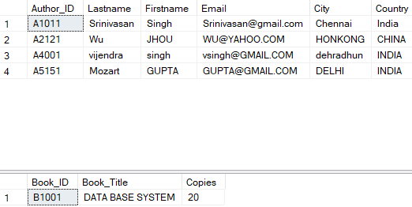

--Alter structure of table AUTHOR_LIST add the field Publisher data type of 30Character.

INSERT INTO AUTHOR_LIST VALUES('A1011', 'B1001', 'publisher');

select * from AUTHOR_LIST; alter table AUTHOR_LIST add Publisher varchar(30);

exec sp_columns AUTHOR_LIST;

select * from AUTHOR_LIST;

**Output:**

